Anaconda setup on shared home directory for SLURM

$ bash /share/downloads/Anaconda3-2020.11-Linux-x86_64.sh

Slave node job submission

- Login to login node using LDAP credentials
$ ssh <username>@192.168.50.160
or
$ ssh <username>@192.168.50.159

Note: LDAP is also used by AIMS.
Your LDAP credentials are the same as AIMS credentials.
- See list of compute/slave nodes you are eligible to use, and make note of the partition name
$ sinfo -l
or
$ sinfo -s

Eg: Unprivileged users can see only allowed partitions

cs18resch01001@slurm-login00:~$ sinfo -s
PARTITION AVAIL TIMELIMIT NODES(A/I/O/T) NODELIST
news-cpu-all up infinite 0/1/0/1 softran4
news-gpu-rtx2080 up infinite 0/1/0/1 gpunode00

Eg. SLURM administrator can see all partitions
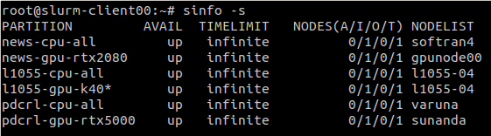

cs18resch01001@slurm-login00:~$ sacctmgr list reservation
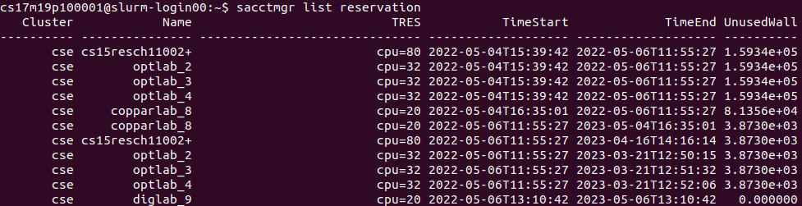

To run an interactive job in foreground
To run a job on any arbitrary node (selected by SLURM node scheduler):

$ srun -p <partition_name> --pty bash
$ srun -p <partition_name> <command>

cs18resch01001@slurm-login00:~$ srun -p news-gpu-rtx2080 --pty bash

cs18resch01001@gpunode00:~$ hostname
gpunode00

cs18resch01001@slurm-login00:~$ sinfo -s
PARTITION AVAIL TIMELIMIT NODES(A/I/O/T) NODELIST
news-cpu-all up infinite 0/1/0/1 softran4
news-gpu-rtx2080 up infinite 1/0/0/1 gpunode00

To run a job exclusively on a specific node:

cs18resch01001@slurm-login00:~$ srun -p news-gpu-rtx2080 --nodelist=gpunode00 --pty bash

To run a job in shared mode on a specific node:

$ srun -p <partition_name> --nodelist=<node_name> --oversubscribe --pty bash
$ srun -p <partition_name> --nodelist=<node_name> --oversubscribe <command>
$ srun -p <partition_name> --nodelist=<node_name> --oversubscribe --reservation=<reservation_name> --pty bash

sanjukumar.chavan@slurm-login01:~$ srun -p news-cpu-all --nodelist=softran2 --oversubscribe --pty bash

sanjukumar.chavan@slurm-login00:~$ srun -p cse-cpu-all --nodelist=cse-node012 --oversubscribe --reservation=copparlab_8 --pty bash
Note: If in case while reserving the SLURM Compute node you see the error
“srun: error: Unable to allocate resources: Requested reservation is invalid”
please use the below command to get the list of reservations created and use the correct reservation ID (Displayed as Name in the screenshot) created for your lab
sanjukumar.chavan@slurm-login00:~$ sacctmgr list reservations
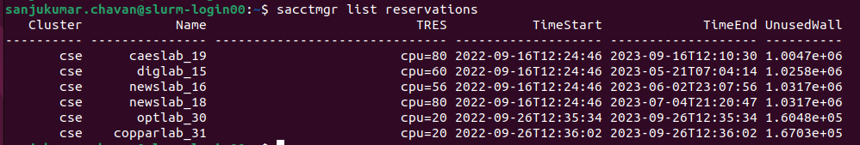

To run an interactive long running job in tmux (or screen)
cs18resch01001@slurm-login01:~$ tmux new -s s1
cs18resch01001@slurm-login01:~$ srun -p news-gpu-rtx2080 --nodelist=gpunode00 --pty bash

To run a batch job in background

Create a script with commands you want to run. You may customize the following script

Eg:
cs18resch01001@slurm-login01:~/slurm/jobs$ cat sample.sh
#!/bin/sh
#SBATCH --job-name=slurm_job_test # Job name
#SBATCH --ntasks=1 # Run on a single CPU
#SBATCH --time=00:20:00 # Time limit hrs:min:sec
#SBATCH --output=test_sample_%j.out # Standard output and error log
#SBATCH --cpus-per-task=1
#SBATCH --partition=news-gpu-rtx2080

echo "SLURM_JOBID="$SLURM_JOBID
echo "SLURM_JOB_NODELIST"=$SLURM_JOB_NODELIST
echo "SLURM_NNODES"=$SLURM_NNODES
echo "SLURMTMPDIR="$SLURMTMPDIR
echo "Date = $(date)"
echo "Hostname = $(hostname -s)"
echo ""
echo "Number of Nodes Allocated = $SLURM_JOB_NUM_NODES"
echo "Number of Tasks Allocated = $SLURM_NTASKS"
echo "Number of Cores/Task Allocated = $SLURM_CPUS_PER_TASK"
echo "Working Directory = $(pwd)"
echo "working directory = "$SLURM_SUBMIT_DIR

pwd; hostname
echo $CUDA_VISIBLE_DEVICES
python3 -c 'print("hello world")'
sleep 10
exit 0

Submit the script as background job

$ sbatch -p <partition_name> <script>
Or
$ sbatch <script>

cs18resch01001@slurm-login01:~/slurm/jobs$ sbatch sample.sh
Submitted batch job 331

To make Slave node available for other user to submit parallel jobs:

$ sbatch -p <partition_name> --nodelist=<node_name> --oversubscribe <script>

sanjukumar.chavan@slurm-login01:~$ sbatch -p news-cpu-all --nodelist=softran2 --oversubscribe hello

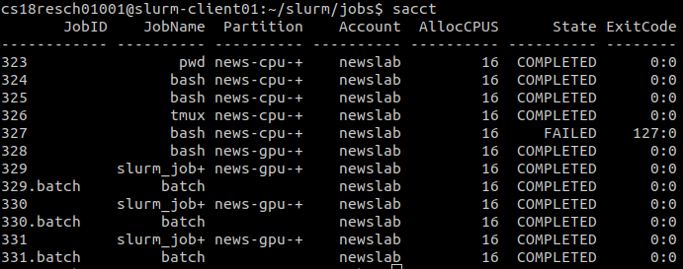

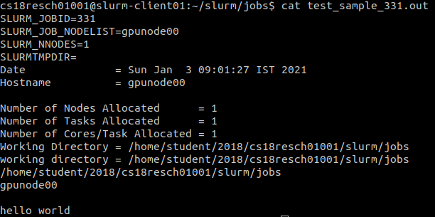

To run a distributed job in foreground

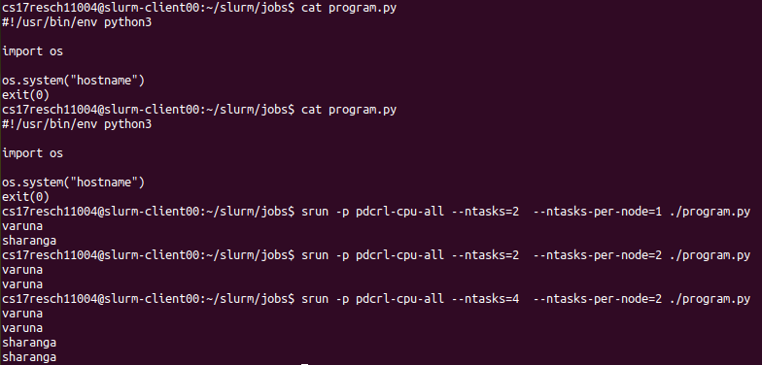

$ srun -p pdcrl-cpu-all -l --ntasks=2 --ntasks-per-node=1 ./program.py
: varuna
0: sharanga

$ srun -p pdcrl-cpu-all -l --ntasks=2 --ntasks-per-node=2 ./program.py
1: varuna
0: varuna

cs17resch11004@slurm-login00:~/slurm/jobs$ srun -p pdcrl-cpu-all -l --ntasks=4 --ntasks-per-node=2 ./program.py
3: varuna
2: varuna
0: sharanga
1: sharanga

Appendix 1 - Slurm production setup

Resource Pool | Node | IP | System | OS
Central Infrastructure | Yamuna node for control plane | 192.168.50.56 (pn50)  192.168.48.56 (bmn48)  192.168.46.56 (sn46) | HP ProLiant DL380 G7  2P/6C/2T (24LCPUs)  96G RAM  1 x 1T HDD | Ubuntu server 20.04
Central Infrastructure | slurm-master00  (slurmctld, slurmdbd) | 192.168.50.163 (pn50)  192.168.48.163 (bmn48)  192.168.46.163 (sn46) | lxd container on yamuna | Ubuntu server 18.04
Central Infrastructure | slurm-master01  (slurmctld, slurmdbd) | 192.168.50.162 (pn50)  192.168.48.162 (bmn48)  192.168.46.162 (sn46) | lxd container on yamuna | Ubuntu server 18.04
Central Infrastructure | slurm-dbserv  (mysql) | 192.168.50.161 (pn50)  192.168.48.161 (bmn48)  192.168.46.161 (sn46) | lxd container on yamuna | Ubuntu server 18.04
Central Infrastructure | slurm-login00  (sinfo, sbatch, sacct, etc) | 192.168.50.160  192.168.48.160 | lxd container on yamuna | Ubuntu server 18.04
Central Infrastructure | slurm-login01  (sinfo, sbatch, sacct) | 192.168.50.159  192.168.48.159 | lxd container on yamuna | Ubuntu server 18.04

- This table does not show the SLURM slaves (CPU nodes, CPU/GPU nodes) so as to maintain isolation of the resources belonging to one research lab.
- Once you login with your userid, you will see list of salve nodes your lab. You cannot see slave nodes belonging to other labs.

